Bopzy Integration with PosLink
21st January 2014
PosLink 1.0.3.17

Introduction
This document will outline the configuration steps for integration with the Bopzy Loyalty System
https://www.bopzy.com/
Please obtain the following credentials from Bopzy before continuing
Merchant Name
Merchant Code
Shared Secret
Bopzy Host URL

The Latest Release for PosLink is 1.0.3.17 for this to work correctly
Setup
- Global Flags – Bopzy Tab
Enter the following details
Merchant Name – Supplied by Bopzy
Merchant Code – Supplied by Bopzy
Points Per Currency – Enter the Number of Points Issued Per £ - If 0 this will auto calculate
Shared Secret – Supplied by Bopzy
Bopzy URL – Supplied by Bopzy
Timeout – Normally set to 10 seconds
Example global flags
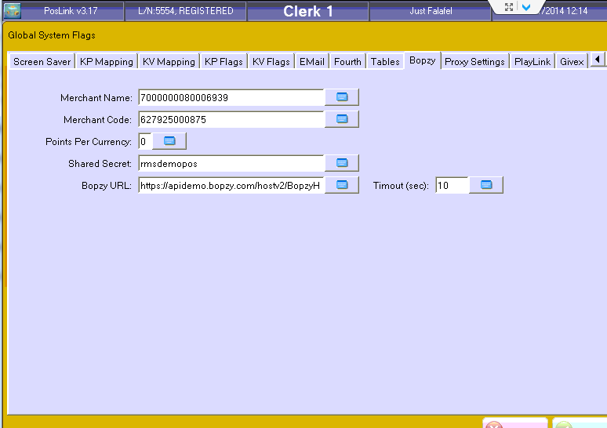

Terminal Config Flag 3
Example
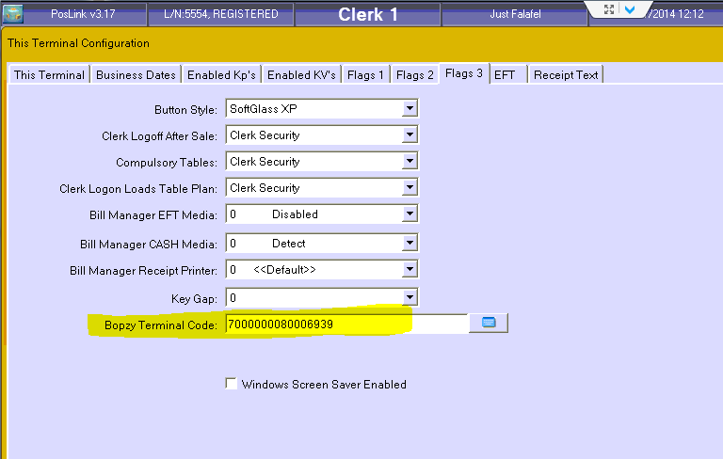
- Bopzy Manual Card Entry
You will need to allocate a Function Key – (181 Enter Bopzy ID). This will allow the till operator to enter or scan a Bopzy Tag into the transaction

- Mag Card Rules
You will need to create a mag card rule for the QR Codes scanning – I have made a rule as follows:
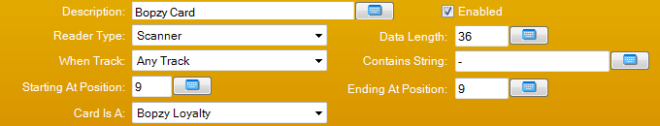
- External Devices
For the Motorola USB Scanner set the Scanner to Comms Mode = USB / USB Port 01
And In USB PORT MAPPINGS for USB01 set the port to (Motorola Scanner)
- Top-up eMoney Balance
If the customer wants to add Money to their eMoney balance we need to setup a PLU as follows
Price = 0.00
Flags 1 = Allow Price Override
Flags 2 = Credit PLU Type = Bopzy Prepay
Allocate this key to your keyboard
- Redeem eMoney Balance
If the customer wants to use Money from there eMoney Balance then we need to setup a MEDIA as follows
Media Type = Bopzy Redeem Prepay
Allocate this button to your Payment Keyboard
- Use Loyalty Points
If the customer wants to use Loyalty Points for redemption on a transaction then we need to setup a MEDIA as follows
Media Type = Bopzy Redeem Points
Allocate this button to your Payment Keyboard
- Check Prepay Balance
If you want the customer to scan a Bopzy Tag to check the Balance of Prepay then allocate function Key (114 – Gift Card Balance) – Set the System to Bopzy on the Flags of the function Key

- Check Loyalty Balance
If you want the customer to scan a Bopzy Tag to check the Balance of Loyalty Points then allocate function Key (97 – Check Loyalty Points) – Set the System to Bopzy on the Flags of the function Key

Operational
When a transaction has a Bopzy Tag scanned then when PosLink does a SUBTOTAL we transmit the sale to the Bopzy system. The Bopzy system then returns the Loyalty Points and any discounts applicable to that sale.
We then apply any discounts to the current sale

A Bopzy QR Code can be scanned any time during a sale and in the Payment screen.

If the Internet is not accessible then this system will not work until the internet is back online and the till operator will be notified that the Bopzy system is back online.

