MyCheck Pay At POS
Setup Guide

Introduction
Poslink can be setup so that a customer presenting a “mycheck Code” can pay at the Point Of Sale by presenting the “MyCheck Code” from a smartphone application to the POS operator.
The POS operator can the press a “Mycheck” media and enter the “MyCheck Code”. This will then communicate to the Mycheck platform and finalise the sale.

Pre-requisites
Internet connection on POS
PosLink 1.0.3.61 or greater

Setup
- Interfaces
Goto Programming
Select Program 78 – Interfaces
Select MyCheck
Enter the URL example: https://test.mycheckapp.com/api/IbsQuickCharge
Enter the Timeout: Example 30
Press SAVE

- Medias
Goto Programming
Select Program 7 – Medias
Press ADDNEW to add a new Media
Enter a description IE MyCheck
Select Media Type “Mycheck”
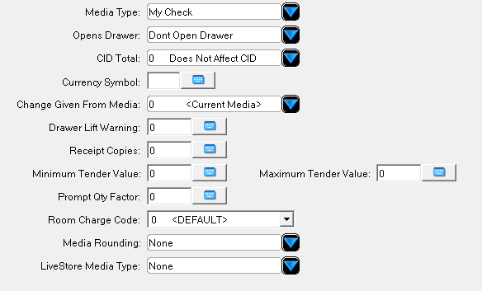

- Payment Keyboard
You need to allocate your media to the payment Keyboard
Goto Programming
Select 16- Payment Keyboard
Drag and drop the Media you created onto the keyboard

Usage

- Enter transaction
- Goto Payment
- Press “Mycheck” media you created
- You will be prompted for the “Mycheck Code”
- Enter the Code presented on the Smartphone Application
- The payment will be processed with Mycheck

