 | Intelligent Business Systems Ltd  St James Road  Brackley  Northants  NN137XY

PosLink PLU Options Setup Guide

PLU Options Setup and usage
Issue 1.0
17/07/2016

Introduction

The PLUOptions functionality enables the user to modify existing PLUS to either remove condiments from the PLU or add condiments to the PLU.
Examples of this are as follows.
Pizza
Sell a Pizza and modify its toppings IE – No cheese / Extra Mushrooms
Burgres
Sell a burger and modify its toppings IE- Extra cheese / No Mayo
Unlike condiments these options can be grouped so the user can only select 1 from a group. Also you can set a factor where after the factor has been reached then the PLU components are charged – IE extras

SetUp
The following guide is a step by step guide. The following example with demonstrate how to setup a Ham and Mushroom Pizza and its modifications.
For the example we need to have some PLUS setup as follows. Just simple PLUS with no price will do.

Cheese
Light Cheese
Extra Cheese

Pan
Thin
Stuffed Crust

No Ham
Ham
No Mushroom
Mushroom
No Pineapple
Pineapple

Plu Options - Program 86
Select this program and Add a new record
We are going to create 3 sections for this screen
- Cheese
- Base
- Toppings
Firstly, select “Add Section” – bottom left. This will add our 1st section where we will select 1 cheese option from. If we now double, click the blank space highlighted in red above the buttons we can now give the section a title. In this example we will call it “Cheese Choice”.
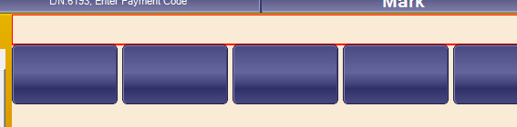
I have 3 PLUS setup
Cheese
Light Cheese
Extra Cheese
Drag the 3 Plus onto the Button Row.
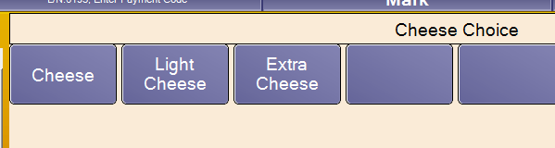

Now we need to Group the 3 Buttons as we are going to allow only 1 choice from this group
To do this highlight all 3 buttons and Press “ADD Group” – bottom left. A red band will show around the group of buttons
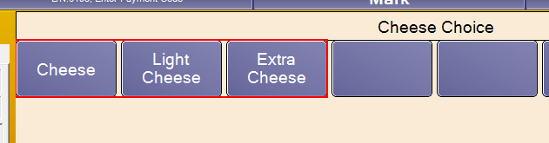

Double Check the Extra Cheese and set the following options as this will occur extra charge to the customer if selected
Factor 1,1 x factor price = £0.50, override Price
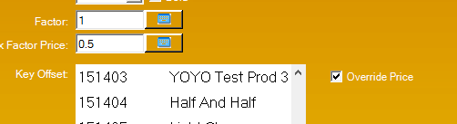

Next we will add the “Base Choices”
To Do this we are going to add a new section. To do this Press “Add Section”
Double click the space above the newly added row and give it a title – “Base Choices”
I have 3 PLUS setup
- Pan
- Thin
- Stuffed Crust
Drag the Base PLUS onto the row and group them as before
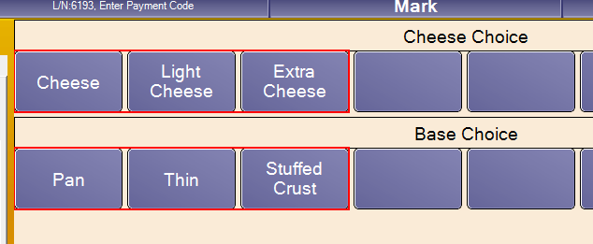

As before the “Stuffed Crust” is 50p extra so double click the “Stuffed Crust” button at set the charge as follows
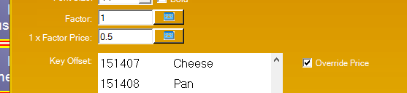

Next stage is to add the toppings available for all our pizzas
Once again we need to add a new section – so press “Add Section”
Give the section a title called “Toppings”
I have setup a few example topping PLUS as follows
Ham
No Ham
Mushroom
No Mushroom
Pineapple
No Pineapple
Peppers
No Peppers
In our restaurant any toppings extra will be charged at 20p
Drag the “no ham” and “ham” plus on the first new row and group them by highlighting both plus and pressing “add group”
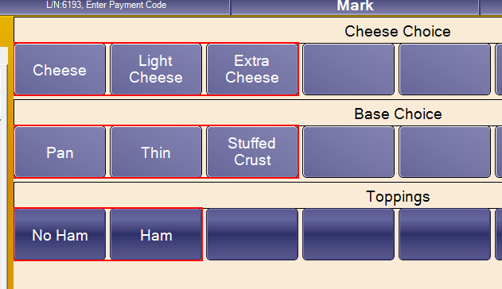

Now we are going to add a new row for the next topping choice. Press “ADD Row”
Drag on “no mushroom” and “mushroom” plus
Do the same process for the Pineapple and Peppers plus so your group looks as follows.
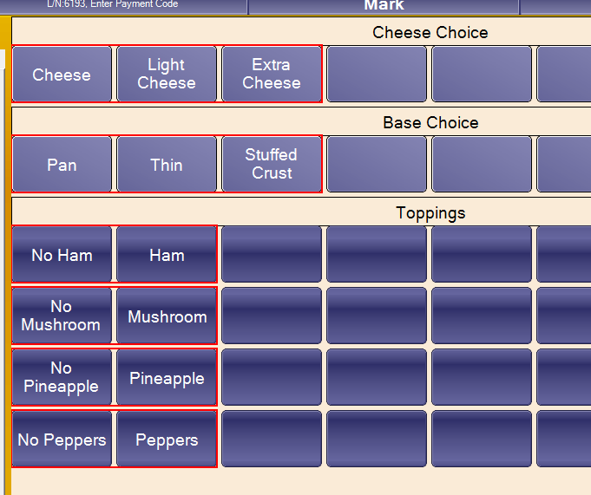

Next we need to select each PLU that is a NO and make it default for the group
So select “No Ham” and press “Make default for Group”
select “No Mushroom” and press “Make default for Group”
select “No Pineapple” and press “Make default for Group”
select “No Peppers” and press “Make default for Group”
This just makes setup easier when linking to the Pizza Plus
For each Chargeable PLU or swap we need to give it a factor and price and tick “Override Price”
Set the following options on each “Ham,Mushroom,Pineapple, and Peppers” PLUS “DO NOT SET ON THE ‘NO’ Items” as these are not chargeable.
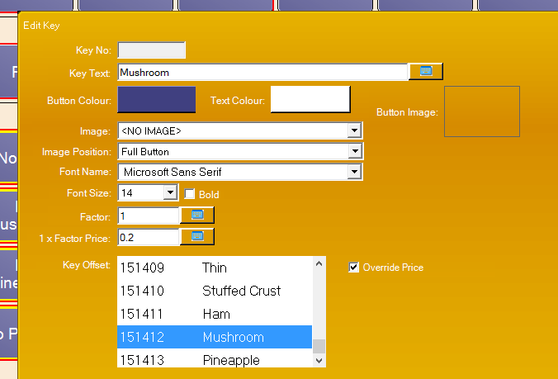

What this means is that for this group if we sell more than we have set on the PLU it will start charging for any extra items the customer orders from that group.
Also “Double Click” the toppings header and select “Use Factors”
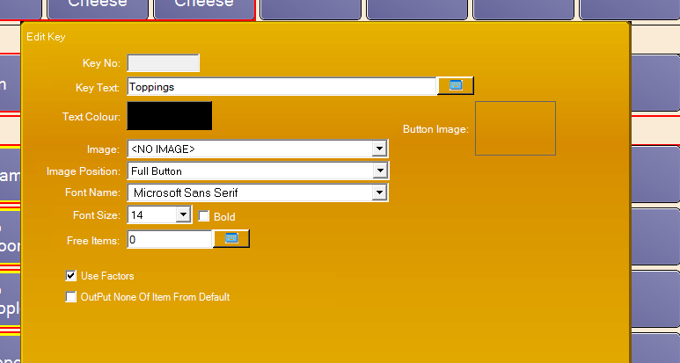

Give this a description “Pizza Options” and Press “Save”
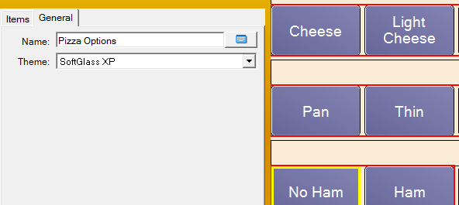

You have now setup a basic template for Pizzas.

Linking the options to the PLU
PLU Program - 4
We need to create a PLU called “Ham and mushroom pizza”.
Setup the PLU in the normal way but on the Tab “PLU Options” we need to select the “PIZZA Options” template
We need to select “HAM” and “Mushroom” as these are the options that make up this Pizza.
Also select Pan and Cheese as these are defaults for this Pizza.

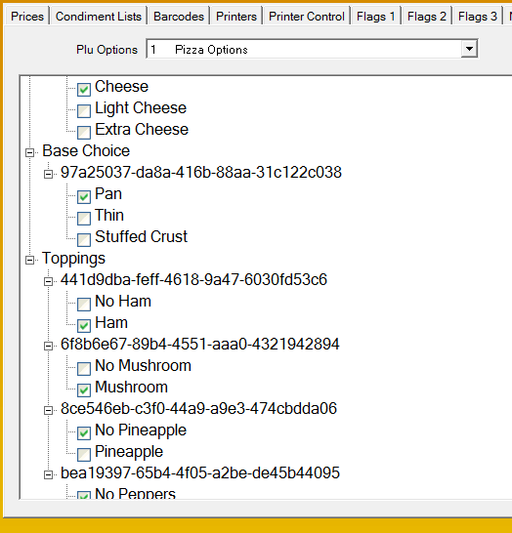

So what we have told the system is that the Ham and Mushroom Pizza has the following from that template. In the toppings group it has ham and mushroom. (we can apply the same template to all our pizzas selecting the toppings that apply to each pizza)
Press SAVE on the PLU.

Creating the “PLU options” function
Functions Program – 12
Create a new function called “PLU Options” – function type 234

Allocate the “PLU options function to the Main Keyboard or Function Bar.
Allocate the “PLU Options” function to a keyboard in the normal way.

Usage.

Sell the “ham and mushroom” pizza.
Now highlight the “ham and mushroom” pizza in the journal and press the function “PLU Options”
You can now modify the PLU
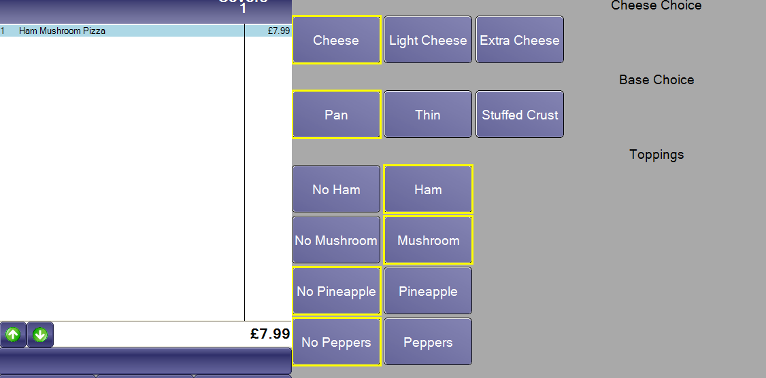
If we add extra toppings, then they get charged. We can remove toppings IE NO ham and we can swap.
When the PLU is modified you press “OK”
