PayPal Payments Setup And Configuration Guide

- Create a PayPal Business Account
Goto
https://www.paypal.com/uk/cgi-bin/webscr?cmd=_registration-run
And create a PayPal for your business Account
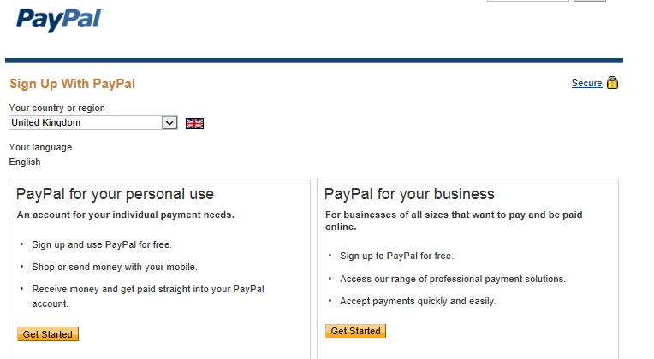

- Settings In PayPal
Once the PayPal Business Account is setup then goto [Profile] – [My Selling Preferences]
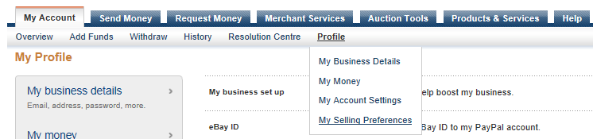

Select API Access - Update
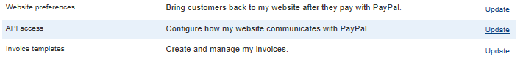
Select Request API credentials
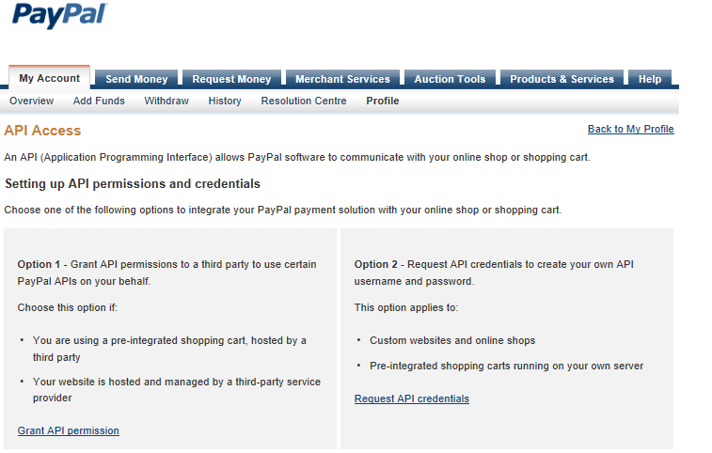
Select “Request API Signature” and Press “Agree and Submit”
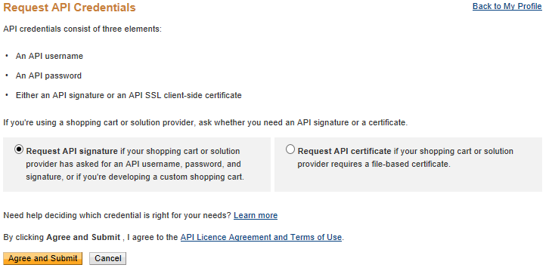

Please Note Down the following – You need to enter these details into stocknet later on
API Username _______________________________________________
API Password_______________________________________________
Signature_______________________________________________
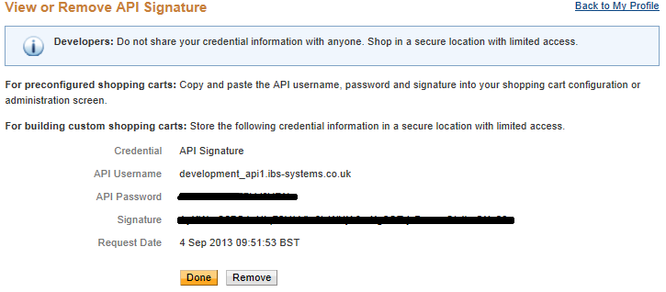

Select Done
Now select [Profile] – [My Selling Preferences] again from the top menu

Select “Instant Payment Notification” - Update

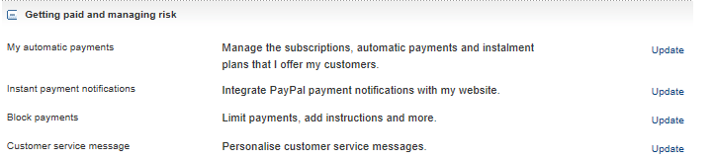

Select “Choose IPN Settings”
You need to enter the URL of your Website so that PayPal can send details of customer’s payments to your system and select “Receive IPN Messages (Enabled)”
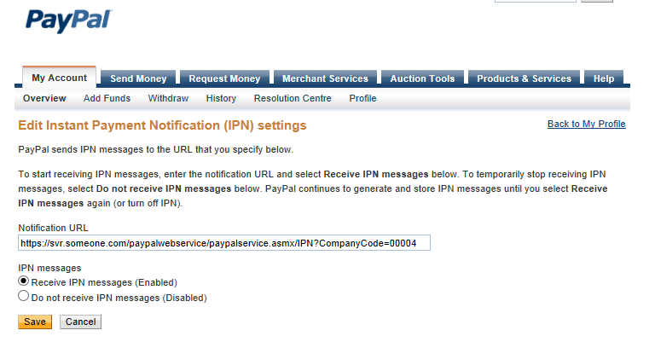
The Notification URL MUST BE HTTPS and must contain the companycode for your stocknet system
Example
https://svr.someone.com/paypalwebservice/paypalservice.asmx/IPN?CompanyCode=00004
Once Complete click SAVE – then select “Back to my profile” – top right of screen

Stocknet Configuration
Login to stocknet
Select “system Maintenance” – PayPal Merchant
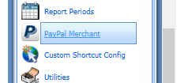
Select “NEW” – to create a new Merchant
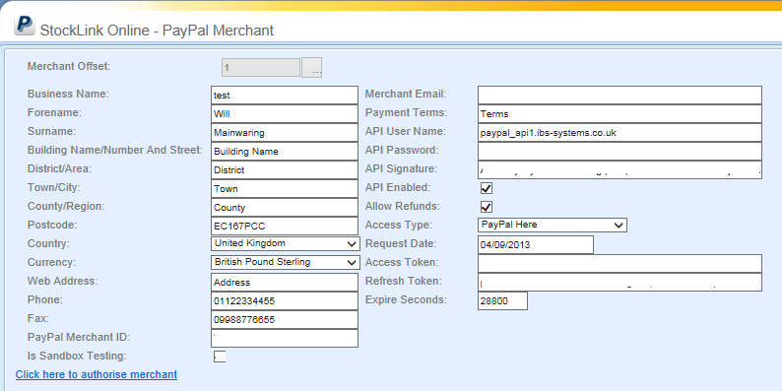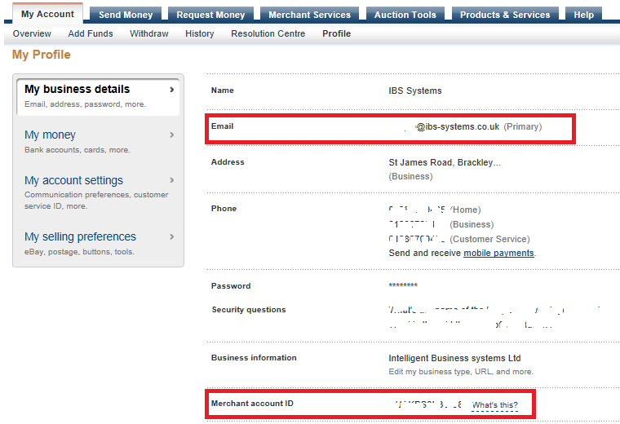
PayPal Merchant ID – You can get this from your Paypal Business Account in My Profile
Merchant Email – This MUST MATCH the email in My Profile
API UserName – Taken from when you did “Request API Credentials”
API Password – Taken from when you did “Request API Credentials”
API Signature – Taken from when you did “Request API Credentials”
Access Token and Refresh Token are filled when the account is Authorised

Click “Click here to authorise merchant” – Enter your paypal logon details and follow the instructions

PosLink Configuration
- Global Flags – StockNet Tab
Enter the URL to the PayPal webservice hosted on your server
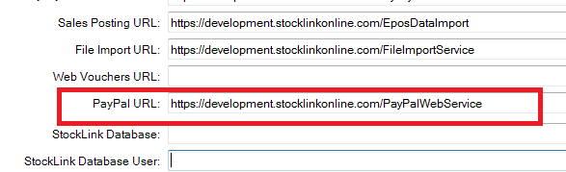
- Medias – Create a PayPal Media
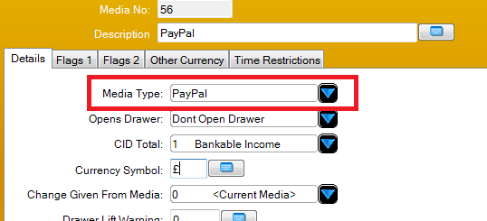
- Allocate the PayPal Media to your Payments Keyboard
- Enable the Location – Select the merchant email on the location you wish to activate
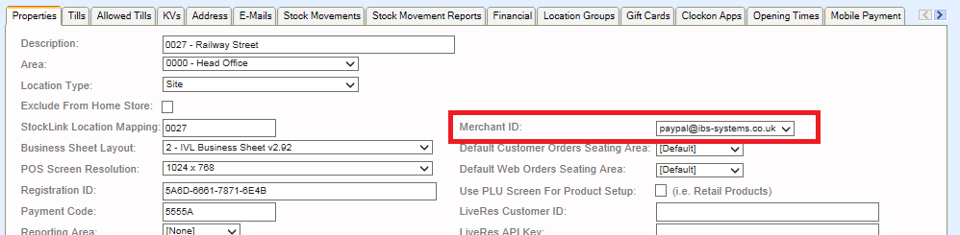

- Opening Times – select the opening Times Tab in Location
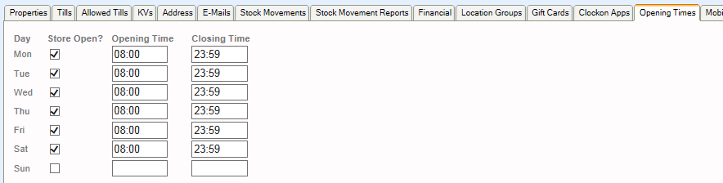

- Address – Select The Address Tab in Location
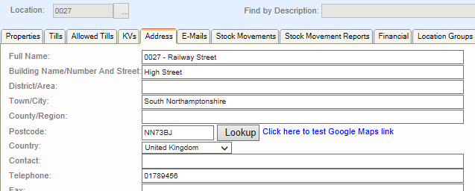

You MUST specify the following fields
Full Name, Building Name/ Number Street, Town City, postcode, Country, Telephone

Store Logos
You can add a logo in the stocknet data folder root for the company IE c:\stocknetdata\00004
The logo file must be JPG and called StoreLogo.Jpg for specific Location logos prefix the file name with the location
Example For companyCode 00004 with a stocknetdata folder of c:\stocknetdata
Example for location 0026 Example Generic Logo
C:\stocknetdata\00004\0026-StoreLogo.jpg c:\stocknetdata\00004\StoreLogo.jpg

SmartPhone / SmartDevice

- Download the PayPal App from your APP store

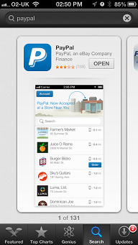

- Sign In with your own PayPal Credentials
- Check Into Your Store using the local button

Pos Operation

- Sell Items
- When customer wants to pay select the PAYPal media
- A list of checked in customers will be displayed

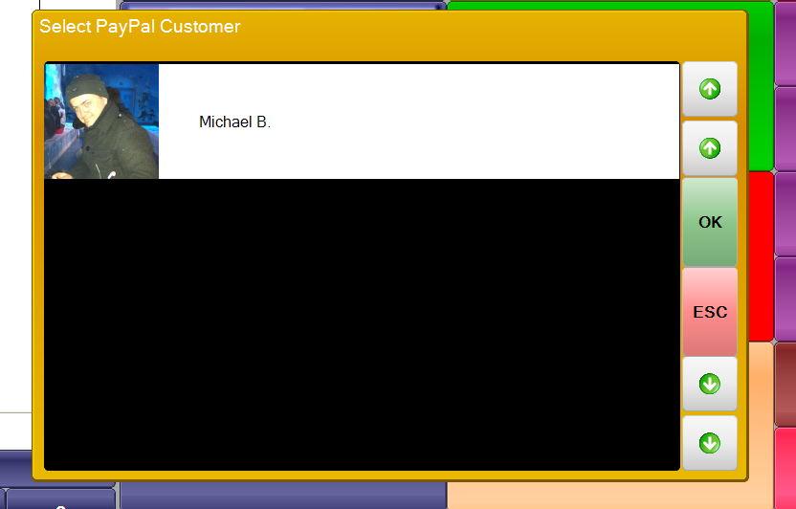

- Select the customer from the list
- Confirm the customer payment
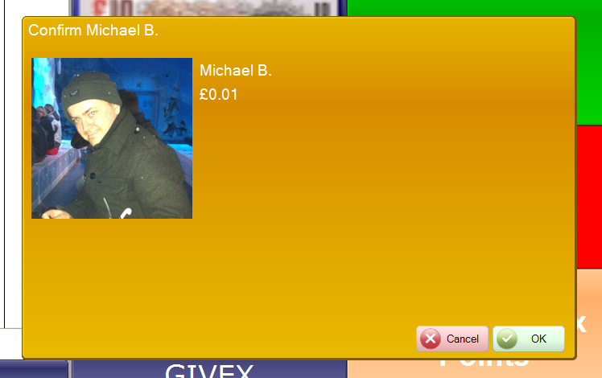

Payment will be made using PayPal.

CheckList
(Points 1 and 2 are only If stocknet is hosted on your own Server)
- Allow IBS to install the PayPalWebservice on your StockNet server
- Access MUST be granted to the service via HTTPS example so your server will need a valid HTTPS certificate for your domain name
https://server1.stocklinkonline.com/paypalwebservice/paypalservice.asmx

- Setup PayPal Business Account
- Setup PayPal Merchant In StockNet
- Configure PosLink To Accept PayPal

Notes
PayPal URL = www.paypal.com – IP 88.221.40.234
IPN Requests come from IP = 173.0.81.1 - 173.0.81.33

IBS Developer Setup – NOT TO BE COMPLETED BY CUSTOMER
This is for IBS to complete ONLY

Logon to

https://developer.paypal.com/webapps/developer/applications/myapps

Create Application
Select LOG IN WITH PAYPAL switch to on
Basic authentication
No information is requested from customers. Only a unique identifier (PPID) is provided to you.
- Personal Information
- Customize
- Full name
- Date of birth
- Age range
- Address Information
- Customize
- Email address
- Street address
- City
- State
- Country
- Zip code
- Phone
- Account Information
- Customize

Return URL = https://svr.somone.com/paypalwebservice/paypalservice.asmx/GetAccessToken
Privacy Policy =
https:// svr.somone.com /paypalwebservice/paypalservice.asmx/privacy
User Agreement
https:// svr.somone.com /paypalwebservice/paypalservice.asmx/user

