PosLink Givex Setup Document For CashLess

- Global Flags – Givex Tab
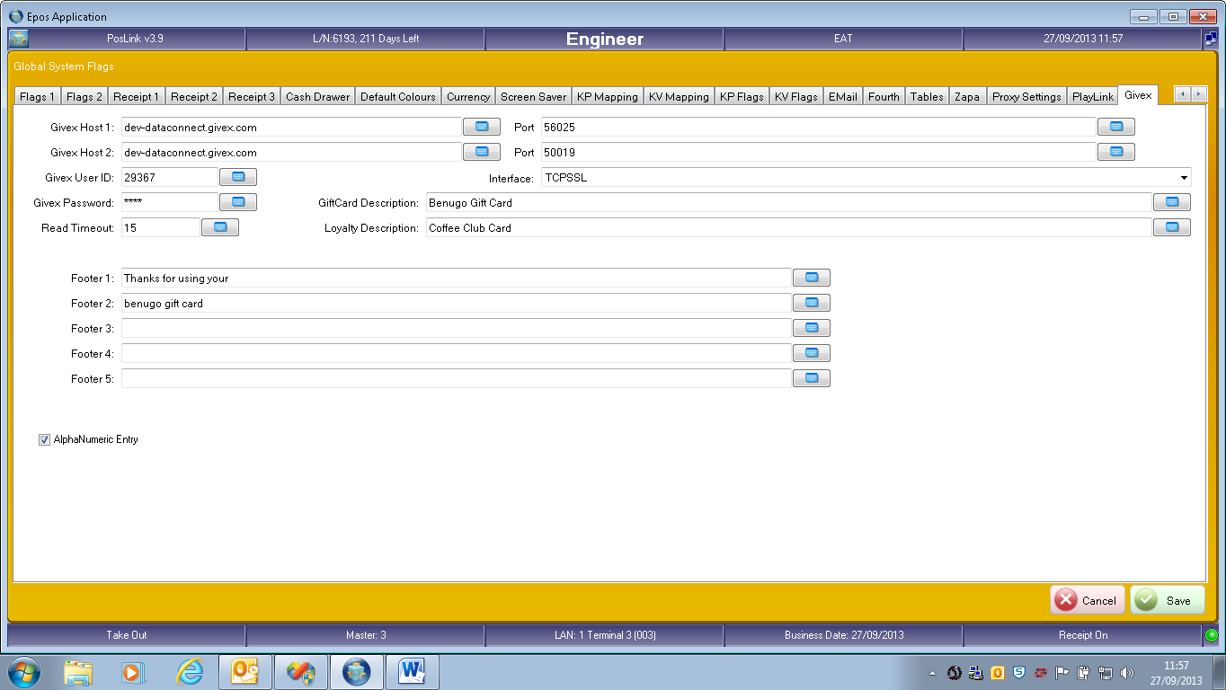
Complete the Givex Settings Supplied by givex
- SELL new givex Card
This is done by creating a PLU with TOPUP type “NEW GIVEX Card”
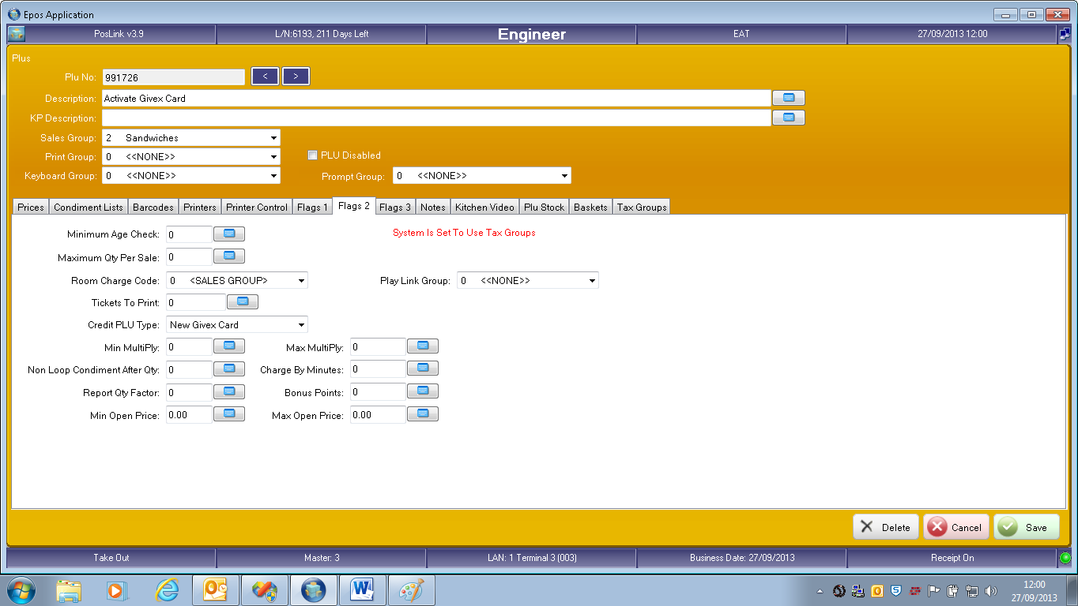

- Topup Existing Givex Card
This is done by creating a PLU with topup type “Credit Givex Card”
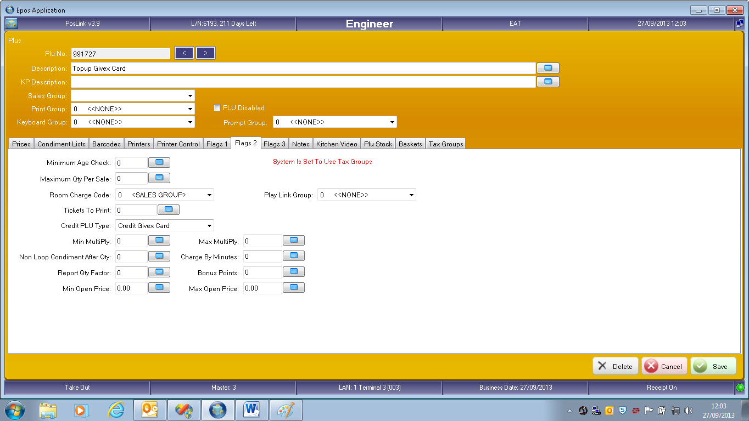

- Pay Using Givex Card
This is done by creating a media with media Type “GIVEX Giftcard”
