PosLink Transaction XML
Initial Release | 1.00 | 6/4/2017

Introduction
This document explains how to setup Transaction XML sending from POSLink. The purpose of this is to send completed transaction data as a HTTP POST request when a sale is finalised.
If the HTTP POST Request fails, then the POS operator is informed of the failure
Configuration
Goto Program Mode – Select Interfaces
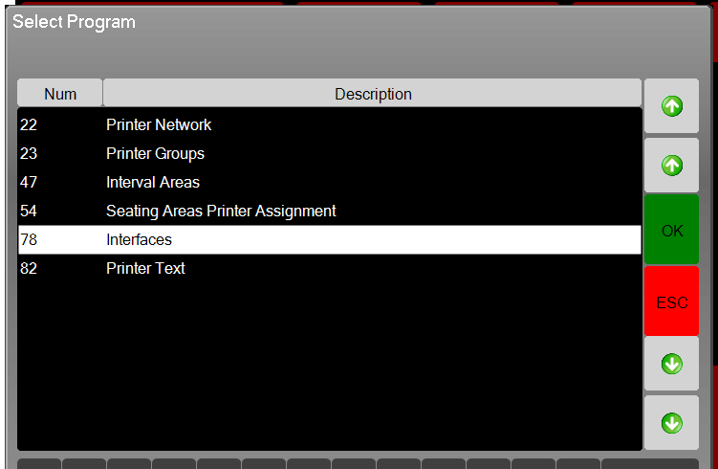
Select Transaction XML
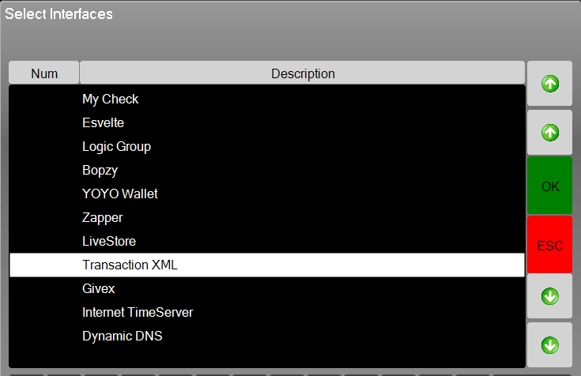

Enter Settings

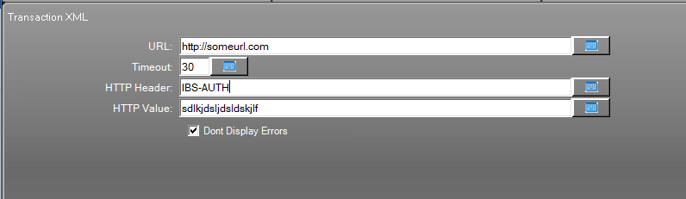

OutPut Format

The whole XML is wrapped in the <PosTransaction> tag
Header
Field | Type | Example | Description
GUID | String | bfb44e97-f835-4d6e-86dc-a5b0e71b854c | Unique ID for each transaction
CompanyCode | String | 00004 | The Company ID of the system
Location | String | 0026 | The Store location number
Busdate | String | 05/06/2015 | Date of the transaction
EcrNo | Int | 23 | The POS ID
BillNo | Long | 10 | The bill / order number
Covers | Int | 2 | Covers total
Refund | Int | 0 | Refund Identifier 1 = refund
TransactionType | Int | 0 | Transaction type  0 = Normal  1 = Wastage  2 = Paid In  3 = Paid Out  4 = No Sale  5 = Void Transaction  6 = Deposit Received  7 = Ledger Settlement
TrackName | String | Mr Webb | A customer name or description associated with the transaction
TrackType | Int | 2 | 1 = Clerk  2 = Table  3 = Tab
TrackOffset | Long | 5 | The Clerk / Table or Tab Number as per tracktype
Training | Int | 0 | 1 = Training Transaction
Total | Double | 19.47 | The Total value of the sale

This will be followed by a series of items using the <Item> tag
Item
Field | Type | Example | Description
ItemKey | Long | 4622888613795069395 | The unique line ID
LinkedItemKey | Long | 0 | If the item is linked in some way to another item
TimeStamp | UTC Date Time | 2015-06-05T12:43:37 | The date/time item was sold
Type | Int | 1 | The type of the line (See LineTypes)
Offset | Long | 1001 | Offset linked to the type (IE type = 1 - Offset is the PLU number)
Description | String | Classic | Description
CorrectStatus | Int | 0 | 0 = not corrected  - = corrected by clerk  - = system corrected
Qty | Int | 1 | Qty sold of item
StockQty | Double | 1 | Qty of item to deduct from stock (IE ½ Lager) = 0.5
Modifier | Int | 1 | Modifier number
PriceLevel | Int | 1 | The PriceLevel Sold At
Weight | Double | 12.45 | The Weight of the PLU if used with scales
ClerkID | Long | 1 | Clerk number
PrintGroup | Int | 20 | Print group number
SalesGroup | Int | 1 | Sales group number
MajorGroup | Int | 1 | Major group number
PrimaryGroup | Int | 1 | Primary group number
Price | Double | 6.75 | The price of the item
TotalValue | Double | 6.75 | The final value of the item
Adjustment | Double | 0.67 | Total adjustment / discount / service applied to this item
Tax | Double | 0.75 | Total Tax/Vat applied to this item

LineTypes
LineType | Description | Meaning
1 | PLU | An Product Item
3 | Adjustment | A discount or service charge (discount is –ve)
2 | Payment | A customer payment IE Cash
10 | Change | The change given back to the customer

Example Data Posted
<PosTransaction>
<GUID>bfb44e97-f835-4d6e-86dc-a5b0e71b854c</GUID>
<CompanyCode>00004</CompanyCode>
<Location>0026</Location>
<BusDate>05/06/2015</BusDate>
<EcrNo>23</EcrNo>
<BillNo>0</BillNo>
<Covers>0</Covers>
<Refund>0</Refund>
<TransactionType>0</TransactionType>
<TrackName></TrackName>
<TrackType>2</TrackType>
<TrackOffset>6</TrackOffset>
<Training>0</Training>
<Total>19.74</Total>
<Item>
<ItemKey>4622888613795069395</ItemKey>
<LinkedItemKey>0</LinkedItemKey>
<Timestamp>2015-06-05T12:43:37</Timestamp>
<Type>1</Type>
<Offset>1001</Offset>
<Description>Classic</Description>
<CorrectStatus>0</CorrectStatus>
<Qty>1</Qty>
<StockQty>1</StockQty>
<Modifier>1</Modifier>
<ClerkID>1</ClerkID>
<PrintGroup>20</PrintGroup>
<SalesGroup>1</SalesGroup>
<MajorGroup>1</MajorGroup>
<PrimaryGroup>1</PrimaryGroup>
<Price>6.75</Price>
<TotalValue>6.75</TotalValue>
<Adjustment>0.67</Adjustment>
<Tax>0.75</Tax>
</Item>
<Item>
<ItemKey>4855459093327172082</ItemKey>
<LinkedItemKey>0</LinkedItemKey>
<Timestamp>2015-06-05T12:43:41</Timestamp>
<Type>1</Type>
<Offset>9403</Offset>
<Description>Medium Well Done</Description>
<CorrectStatus>0</CorrectStatus>
<Qty>1</Qty>
<StockQty>1</StockQty>
<Modifier>1</Modifier>
<MainItemKey>4622888613795069395</MainPluKey>
<ClerkID>1</ClerkID>
<PrintGroup>20</PrintGroup>
<SalesGroup>34</SalesGroup>
<MajorGroup>1</MajorGroup>
<PrimaryGroup>1</PrimaryGroup>
<Price>0.00</Price>
<TotalValue>0.00</TotalValue>
</Item>
<Item>
<ItemKey>4670633025822053688</ItemKey>
<LinkedItemKey>0</LinkedItemKey>
<Timestamp>2015-06-05T12:43:43</Timestamp>
<Type>1</Type>
<Offset>1002</Offset>
<Description>Cheese</Description>
<CorrectStatus>0</CorrectStatus>
<Qty>1</Qty>
<StockQty>1</StockQty>
<Modifier>1</Modifier>
<ClerkID>1</ClerkID>
<PrintGroup>20</PrintGroup>
<SalesGroup>1</SalesGroup>
<MajorGroup>1</MajorGroup>
<PrimaryGroup>1</PrimaryGroup>
<Price>7.95</Price>
<TotalValue>7.95</TotalValue>
<Adjustment>0.80</Adjustment>
<Tax>0.88</Tax>
</Item>
<Item>
<ItemKey>5118430836022027307</ItemKey>
<LinkedItemKey>0</LinkedItemKey>
<Timestamp>2015-06-05T12:43:44</Timestamp>
<Type>1</Type>
<Offset>9401</Offset>
<Description>Medium Rare</Description>
<CorrectStatus>0</CorrectStatus>
<Qty>1</Qty>
<StockQty>1</StockQty>
<Modifier>1</Modifier>
<MainItemKey>4670633025822053688</MainPluKey>
<ClerkID>1</ClerkID>
<PrintGroup>20</PrintGroup>
<SalesGroup>34</SalesGroup>
<MajorGroup>1</MajorGroup>
<PrimaryGroup>1</PrimaryGroup>
<Price>0.00</Price>
<TotalValue>0.00</TotalValue>
</Item>
<Item>
<ItemKey>5604487589200165168</ItemKey>
<LinkedItemKey>0</LinkedItemKey>
<Timestamp>2015-06-05T12:43:45</Timestamp>
<Type>1</Type>
<Offset>2301</Offset>
<Description>Chunky Fries</Description>
<CorrectStatus>0</CorrectStatus>
<Qty>1</Qty>
<StockQty>1</StockQty>
<Modifier>1</Modifier>
<ClerkID>1</ClerkID>
<PrintGroup>30</PrintGroup>
<SalesGroup>9</SalesGroup>
<MajorGroup>1</MajorGroup>
<PrimaryGroup>1</PrimaryGroup>
<Price>3.25</Price>
<TotalValue>3.25</TotalValue>
<Adjustment>0.32</Adjustment>
<Tax>0.36</Tax>
</Item>
<Item>
<ItemKey>5694851671862970181</ItemKey>
<LinkedItemKey>0</LinkedItemKey>
<Timestamp>2015-06-05T12:43:46</Timestamp>
<Type>3</Type>
<Offset>1000</Offset>
<Description>Service Charge</Description>
<CorrectStatus>0</CorrectStatus>
<Qty>1</Qty>
<StockQty>1</StockQty>
<Modifier>0</Modifier>
<ClerkID>1</ClerkID>
<PrintGroup>0</PrintGroup>
<SalesGroup>0</SalesGroup>
<MajorGroup>0</MajorGroup>
<PrimaryGroup>0</PrimaryGroup>
<Price>0.00</Price>
<TotalValue>1.79</TotalValue>
</Item>
<Item>
<ItemKey>5406447186839424558</ItemKey>
<LinkedItemKey>0</LinkedItemKey>
<Timestamp>2015-06-05T12:43:47</Timestamp>
<Type>2</Type>
<Offset>8</Offset>
<Description>CASH</Description>
<CorrectStatus>0</CorrectStatus>
<Qty>1</Qty>
<StockQty>1</StockQty>
<Modifier>0</Modifier>
<ClerkID>1</ClerkID>
<PrintGroup>0</PrintGroup>
<SalesGroup>0</SalesGroup>
<MajorGroup>0</MajorGroup>
<PrimaryGroup>0</PrimaryGroup>
<Price>0.00</Price>
<TotalValue>50.00</TotalValue>
</Item>
<Item>
<ItemKey>5060869660202464759</ItemKey>
<LinkedItemKey>0</LinkedItemKey>
<Timestamp>2015-06-05T12:43:47</Timestamp>
<Type>10</Type>
<Offset>8</Offset>
<Description>Change</Description>
<CorrectStatus>0</CorrectStatus>
<Qty>1</Qty>
<StockQty>1</StockQty>
<Modifier>0</Modifier>
<ClerkID>1</ClerkID>
<PrintGroup>0</PrintGroup>
<SalesGroup>0</SalesGroup>
<MajorGroup>0</MajorGroup>
<PrimaryGroup>0</PrimaryGroup>
<Price>0.00</Price>
<TotalValue>30.26</TotalValue>
</Item>
</PosTransaction>

